
Ethiopian Food and Drug Authority

Guidance on Grouping of Medical Device for Registration

May 2019
Addis Ababa, Ethiopia

Contents
1.0 Introduction 3
2.0 Purpose 3
3.0 Scope 3
4.0 Terms and Definitions 3
5.0 General Principles of Grouping 5
6.0 Categories 6
6.1 Single 6
6.2 System 7
6.3 Family 9
6.4 SET 11
6.5 IVD Test Kit 13
ANNEX 1: Decision Flowchart For Grouping of Products as a System 15
ANNEX 2: Decision Flowchart for Grouping of Medical Devices as a Family 16
ANNEX 3: Permissible Variants in a Family 17
ANNEX 4: Special Grouping Rule for Class A Reusable 19
ANNEX 5: Decision Flowchart for Grouping of Products as a IVD Test Kit 21

Introduction
Under the Food and Medicine Administration Proclamation 1112/2019, the manufacturer or the Local Authorized Representative of the foreign manufacturer is required to register a medical device before importing, exporting or placing it in the Ethiopia market.
There is a wide range of medical devices from a simple medical device to a highly complex and sophisticated medical device. The various components can be sold as a separate component, individual customized pack or group and can be categorized as SINGLE, FAMILY, SYSTEM, SET, IVD TEST KIT, and IVD CLUSTER. Each of the categories mentioned can be submitted in the medical device registration application.

Purpose
The purpose of this document is to provide guidance to determine the appropriate grouping for medical devices in the medical device registration application.

Scope
This guidance document applies to all products that fall within the definition of medical device that has been specified in the national laws.

Terms and Definitions
For the purpose of this guidance document the following definitions are used
Accessory mean an accessory is an article that is intended specifically by its manufacturer to:
- be used together with a medical device to enable that device to be used in accordance with its intended purpose as a medical device; or
- to augment or extend the capabilities of that device in fulfillment of its intended purpose as a medical device.
and therefore, should be considered as a medical device.
Component mean one of several possibly unequal subdivisions which together constitute the whole medical device to achieve the latter’s intended purpose. A component may be known as a part but not a medical device in its own right.
Generic Proprietary Name mean a unique name given by the manufacturer to identify a medical device as a whole product, also known as the trade name or brand name.
Intended Purpose mean the use for which the medical device is intended according to the specifications of its manufacturer as stated on any or all of the following:
- the label of the medical device;
- the instructions for use of the medical device;
- the promotional materials in relation to the medical device.
Authorized local agent (representative) means any company or legal person established within a country or jurisdiction who has received a mandate from the manufacturer to act on its behalf for specified tasks with regard to the manufacturer ‘s obligations under the legislation of medical devices and other regulatory guidance‘s issued by the Authority
Manufacturer: means ―
- any person who is responsible for ―
  - the design, production, fabrication, assembly, processing, packaging and labeling of a medical device whether or not it is the person, or a subcontractor acting on the person’s behalf, who carries out theses operations; and
  - assigning to the finished medical device under his own name, its intended purpose and for ensuring the finished product meets the regulatory requirement; or
- any other person who ―
  - assembles, packages, processes, fully refurbishes, reprocess or labels one or more ready-made medical devices; or
  - assigns to them their intended purpose as a medical device under his own name;
but shall not include the following persons:
- any person who assembles or adapts the medical device in the market that is intended for an individual patient; and
- any person who assembles, packages or adapts the medical device to which the assembling, packaging or adaptation does not change the purpose intended for the medical device.
Reusable Surgical Instrument: Instrument intended for surgical use by cutting, drilling, sawing, scratching, scraping, clamping, retracting, clipping or other surgical procedures, without connection to any active medical device and which are intended by the manufacturer to be reused after appropriate procedures for cleaning, disinfection and/or sterilization have been carried out.

General Principles of Grouping
  - Medical devices that can be grouped into one of the following five categories can be submitted in one application for product registration:
- SINGLE,
- FAMILY,
- SYSTEM
- SET
- IVD TEST KIT,
- IVD CLUSTER
  - Three basic rules must all be fulfilled for the grouping to apply. These are:
- one generic proprietary name;
- one manufacturer; and
- one common intended purpose.
  - For the purpose of grouping, the corporate headquarters may be regarded as the manufacturer for its subsidiaries and regional manufacturing sites.

Instruments

Subsidiary A
Screws
Manufacturer C

Instruments
Manufacturer D

Plates
Manufacturer B

TRS MDB ORTHOPAEDIC SYSTEM Orthopedic System
(Headquarters)

Figure 1: Example of referencing the headquarters as the manufacturer for the purpose of grouping
  - For example, TRS MDB ORTHOPAEDIC SYSTEM consists of the following constituent components (refer to Figure 1):
- Instruments from Manufacturer A (a subsidiary of TRS MDB Malaysia),
- Instruments from Manufacturer D (a subsidiary of TRS MDB Mexico),
- Plates from Manufacturer B; and
- Screws from Manufacturer C
For grouping, the manufacturer of TRS ORTHOPAEDIC SYSTEM will be TRS MDB Malaysia (Headquarters).

Categories

Single
A Single medical device is a medical device from a manufacturer identified by a medical device proprietary name with a specific intended purpose. It is sold as a distinct packaged entity and it may be offered in a range of package sizes.
Examples:
- Condoms that are sold in packages of 3, 12 and 144 can be registered as a SINGLE medical device.
- A company manufactures a software program that can be used with a number of CT scanners produced by other manufacturers. Although the software cannot function on its own, it can be used on different scanners. The software can be registered as a SINGLE medical device.
- A company that assembles and registers a first aid kit has now decided to also supply each of the medical devices in the first aid kit individually. Each medical device supplied individually must be registered separately as a SINGLE medical device.

System
A medical device SYSTEM comprises of a number of constituent-components that are:
- from the same manufacturer;
- intended to be used in combination to complete a common intended purpose;
- compatible when used as a SYSTEM; and
- sold under a SYSTEM name or the labeling, instruction for use (IFU), brochures or catalogues for each constituent component states that the constituent component is intended for use with the SYSTEM.
NOTE Constituent-components registered as part of a system shall only be supplied specifically for use with that SYSTEM. Any constituent-component that is meant for supply for use with multiple SYSTEMs should be registered together with each of these other SYSTEMs. Alternatively, these constituent-component(s) that are compatible for use with multiple SYSTEMs must be registered separately.
The decision flowchart for grouping of products as an SYSTEM can be found in Annex 1.
In addition, if several SYSTEMs fulfill the following conditions to be grouped as a FAMILY, they may be registered as a FAMILY:
- the SYSTEMs are from the same manufacturer;
- the SYSTEMs are of the same risk classification class;
- the SYSTEMs have a common intended purpose;
- the SYSTEMs have the same design and manufacturing process; and
- key constituent-components of the SYSTEMs have variations that are within the scope of the permissible variants.
- has the same generic proprietary name
Individual SYSTEM names may contain additional descriptive phrases.
The applicant has to undertake the following post-market duties and obligations for all the constituent-components in the registered SYSTEM, regardless of whether the constituent components are from the same product owner of the SYSTEM:
- comply with the conditions applicable to the registered medical device and conditions imposed on the applicant;
- submit applications to the Authority for changes made to the registered medical device;
- maintain records of supply;
- maintain records of complaints;
- report defects and adverse effects to the Authority, and
- notify the Authority concerning field safety corrective action (FSCA), including recall.
An In Vitro Diagnostic (IVD) Medical Device SYSTEM may typically consist of TEST KITs and instruments (e.g. an analyser designed to be used with that TEST KIT).
Examples:
- A hip replacement SYSTEM comprising of femoral and acetabular components can be registered as a SYSTEM. The components must be used in combination to achieve a common intended purpose of total hip replacement. The size of the components may vary.
- An electrosurgical unit and its accessories that consist of forceps, electrodes, electrode holders, leads, plug adaptor, when used together for a common intended purpose, can be registered as a SYSTEM.
- Optional accessory such as wireless controller is part of In-the-ear hearing aid can be registered as a SYSTEM.
- A glucose monitoring SYSTEM comprising of a glucose meter, test strips, control solutions and linearity solutions can be registered as a SYSTEM.

Family
A medical device FAMILY is a collection of medical devices and each medical device FAMILY member:
- is from the same manufacturer;
- is of the same risk classification;
- has the same generic proprietary name;
- has a common intended purpose;
- has the same design and manufacturing process; and
- has variations that are within the scope of the permissible variants.
The decision flowchart for grouping of products as a FAMILY can be found in Annex 2.
A characteristic of a medical device may be considered a permissible variant if:
- the physical design and construction of the medical devices are the same, or very similar;
- the manufacturing processes for the medical devices are the same, or very similar;
- the intended purpose of the medical devices is the same; and
- the risk profile of the medical devices, taking into account the above factors, is the same.
See Annex 3 for a list of permissible variants in a FAMILY.
If medical devices satisfy the above conditions to be grouped as a FAMILY, but have different device proprietary names, the products will be listed separately based on their proprietary name.
Information on all medical devices within a FAMILY must be submitted as part of one product registration application. Only members of a FAMILY that are eventually listed on the register shall be supplied on the market. Those that are not listed shall not be supplied on the market.
The medical device proprietary name must appear on the label of each of the member medical devices. Individual medical device names may contain additional descriptive phrase.
A special grouping rule is applicable for Class I/A reusable surgical instruments. See Annex 4 for this grouping rule.
Examples:
- Condoms that differ in colour, size and texture but are manufactured from the same material and manufacturing process and share a common intended purpose can be registered as a FAMILY.
- IV administrative sets that differ in features such as safety wings and length of tubing, but are manufactured from the same material and manufacturing process and share a common intended purpose can be registered as a FAMILY.
- Steerable guidewires that are available in various lengths and possess various tip shapes and tip flexibilities can be registered as a FAMILY if their variations fall within the scope of permissible variants.
- Spherical contact lens with additional features of UV protection, can be registered as part of a FAMILY, as this feature does not affect the basic design and manufacturing of the lens.
- In-the-ear hearing aids which are designed in different sizes to be fitted in the ear (i.e. outer ear, middle ear, and inner ear canal), and have been designed using the same main components including the signal processor and compression circuit, microphone, amplifiers, and receiver, can be registered as a FAMILY.
- Automated blood pressure monitors with optional features such as memory storage and print capability can be considered as part of a FAMILY.
- Cardiac catheters that are available in a different number of lumens, lengths and diameters can be registered as a FAMILY.
- Contact lenses are available as toric lens and spherical lens. These products have different intended purposes and performances. They are designed and manufactured differently. Due to these differences, they shall not be considered as members of a FAMILY. Singapore, example
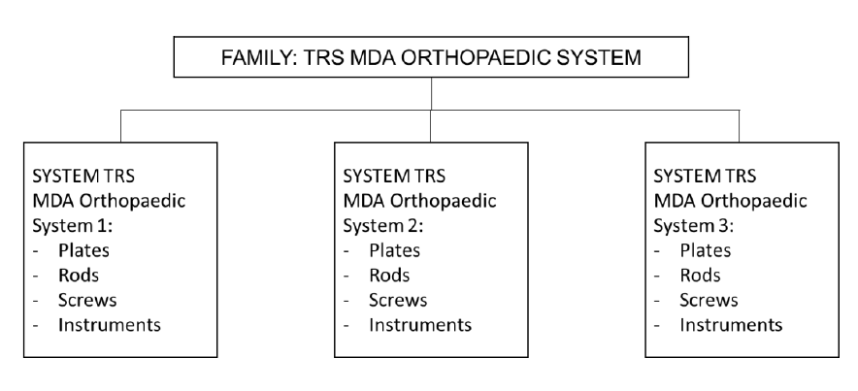
Note: The key constituent-components, i.e. implantable rods, plates and screws, across the Systems are within permissible variants. For example, differences in lengths of the implantables screws are deemed permissible variants.
Figure 2: Example on Grouping of Systems as a Family
Information on all the constituent-components within a System must be submitted as part of one product registration application. Only constituent- components within a SYSTEM that are eventually on the register shall be supplied on the market. Those that are not listed shall not be supplied on the market
It the constituent-component in a SYSTEM is supplied for use in more than one SYSTEM, such as constituent-components shall be included in the registration application for each of the other SYSTEMs.

SET
A medical device SET is a collection of two or more medical devices, assembled together as one package by a manufacturer. The medical device SET has the following characteristics:
- a single proprietary SET name, and
- a common intended purpose
- classification allocated to the set is at the level of the highest classified device within the set.
Each medical device in the SET may have different design and manufactured by different manufacturers.
When the SET is registered, the manufacturer is able to customize the set for particular hospitals or physicians, while maintaining the same SET name and intended purpose. When the SET is registered, all other combinations in that SET can be supplied on the market.
Information on all medical devices within a SET must be submitted as part of one product registration application. Only medical devices within a SET that are eventually listed on the register shall be supplied on the market. Those that are not listed shall not be supplied on the market. Medical devices that are registered as part of a SET must have a SINGLE medical device registration before they are sold separately as individual medical devices.
If a medical device in a SET is supplied for use in another SET, such a medical device shall be included in the registration application of that other SET.
The SET name indicated for the medical device must appear in the product label affixed on the external package of the SET. Individual medical devices in the SET do not require to be labelled with that SET name. Individual medical devices in the SET may contain additional descriptive phrases.
The Applicants has to undertake the following post-market duties and obligations for all the constituent-components in the registered SET, regardless of whether the constituent-components are from the same manufacturer of the SET:
- comply with the conditions applicable to the registered medical device and conditions imposed on the Registrant;
- submit applications to the Authority for changes made to the registered medical device;
- maintain records of supply;
- maintain records of complaints;
- report defects and adverse effects to the Authority and
- notify the Authority concerning field safety corrective action (FSCA), including recall.
Examples:
  - A first aid kit consisting of medical devices such as bandages, gauzes, drapes and thermometers, when assembled together as one package by a manufacturer, can be registered as a SET.
  - A dressing tray consisting of a number of medical devices when packaged together for convenience to meet a specific purpose by a manufacturer can be can be registered as a SET.
  - A manufacturer supplies dressing trays customised with different quantity and type of gauze and sutures to different hospitals while maintaining the same SET name and intended purpose.
  - A promotional pack consisting of different number of medical devices, for example multipurpose solution, saline solution, and contact lens case, will not require a SET registration. Individual medical devices shall require registration as SINGLE medical devices

IVD Test Kit
An IVD TEST KIT is an in vitro diagnostic (IVD) device that consists of reagents or articles that are:
  - from the same manufacturer;
  - intended to be used in combination to complete a specific intended purpose;
  - sold under a single TEST KIT name or the labeling, instructions for use (IFU), brochures or catalogues for each reagents or article states that the component is intended for use with the IVD TEST KIT; and
  - compatible when used as a TEST KIT.
An IVD TEST KIT does not include the instruments, such as analysers, needed to perform the test.
The decision flowchart for grouping of products as an IVD TEST KIT can be found in Annex 5.
Information on all reagents or articles within an IVD TEST KIT must be submitted as part of one product registration application. Only those reagents or articles within an IVD TEST KIT that are eventually listed on the register shall be supplied on the market. Those that are not listed shall not be supplied on the market.
Individual reagents or articles can be supplied separately as replacement items for the kit. If the reagents or articles in a TEST KIT are supplied for use in more than one TEST KIT, such reagents or articles shall be included in the product registration application of each of the other TEST KITS.
Reagents or articles from another manufacturer may be registered with the IVD TEST KIT. The Applicants has to undertake the following post-market duties and obligations for all the reagents and articles in the registered IVD TEST KIT, regardless of whether the reagents or articles are from the same manufacturer of the IVD TEST KIT:
- comply with the conditions applicable to the registered medical device and conditions imposed on the Registrant;
- submit applications to the Authority for changes made to the registered medical device;
- maintain records of supply;
- maintain records of complaints;
- report defects and adverse effects to the Authority and
- notify the Authority concerning field safety corrective action (FSCA), including recall.
Examples:
A Human Immunodeficiency Virus (HIV) Enzyme Linked ImmunoSorbent Assay
(ELISA) TEST KIT may contain controls, calibrators and washing buffers. All the reagents and articles are used together to detect HIV and therefore can be registered as a TEST KIT. These reagents and articles can be supplied separately as replacement items for that particular TEST KIT but must be registered as a SINGLE IVD device.

IVD Test Cluster
An IVD CLUSTER comprises of a number of in vitro diagnostic reagents or articles that are:
- from the same manufacturer;
- within risk classification A or B;
- of a common test methodology as listed in Annex 6; and
- of the same IVD CLUSTER category as listed in Annex 6.
The IVD CLUSTER may include analysers that are designed for use with the reagents in the IVD CLUSTER.
A closed list of common test methodologies and IVD CLUSTER categories is provided in Annex 6.
The decision flowchart for grouping of products as an IVD CLUSTER can be found in Annex 7.
Information on all reagents or articles within an IVD CLUSTER must be submitted as part of one product registration application. Only those reagents or articles within an IVD CLUSTER that are eventually listed on the register shall be supplied on the market. Individual reagents or articles that are listed as part of a CLUSTER can be supplied separately.
If a reagent or article is intended for multiple usage categories such that it can be grouped in more than one IVD CLUSTER, the Registrant can choose to group the reagent or article as part of any one of the IVD CLUSTERs it qualifies. Information to support all the intended purposes of the reagent or article must be submitted as part of the product registration application.
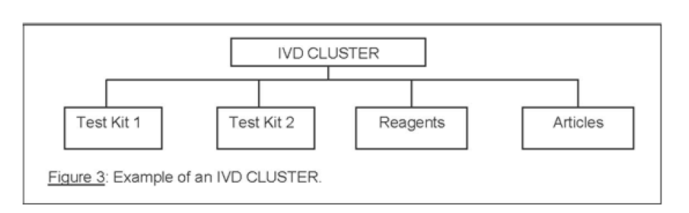
Figure 3 Example of an IVD CLUSTER
Individual (single) reagents or articles, test kits or families of reagents or articles within an IVD CLUSTER (Figure 3), shall be listed separately on the Medical Device Register.

ANNEX 1: Decision Flowchart For Grouping of Products as a System
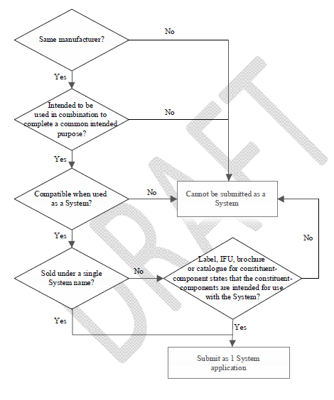

ANNEX 2: Decision Flowchart for Grouping of Medical Devices as a Family
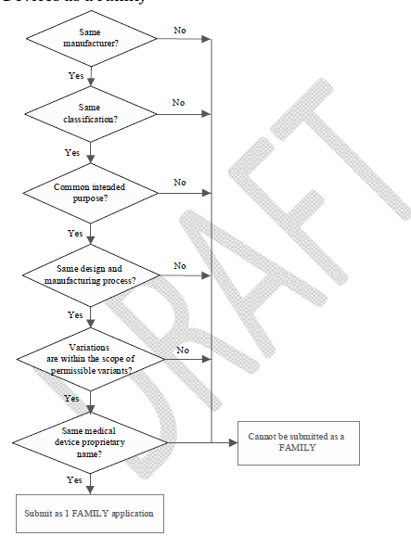

ANNEX 3: Permissible Variants in a Family
The list of permissible variants is a closed and positive list.
Specific products | Permissible variants
Antibiotic test | (i) Concentrations
Catheter | (i) Number of lumens in catheter  (ii) Material of catheter: PVC (polyvinylchloride), PU  (polyurethane), nylon and silicone  (iii) Curvature (straight or pigtail)  Polymer products-with or without DEPH  Stent- delivery system, that is over-the –wire or through the scope
I V cannula | - Presence of injection port  - Presence of safety wing
Condoms | (i) Texture  (ii) Flavour
Contact lens | (i) Diopter,  (ii) UV protection  (iii) Tinting
Electrophysiological  Catheter | (i) Electrode spacing  (ii) ) Number of electrodes
Suture | (i) Number of strands  (ii) Pledgets
Suture passer | (i) Design of jaw, handle or needle
Dental handpieces | (i) Rotational speed  (ii) Material of handpiece
Dental brackets | (i) Material of bracket
IVD rapid tests | (i) Different assembly format: cassette, midstream, strip
IVD urinalysis strips | (i) Different combination of testing configurations
Polymer Products | (i) With or Without DEHP
Stent | 1)Delivery system, that is over –the-wire or through the scope

Other permissible variants in general
Colour
Diameter
Flexibility
Gauge
Holding force
Isotope activity level
Length
Memory storage
Print capability
Radiopacity
Shape
Size
Volume
Width
Viscosity (The change in viscosity is solely due to changes in the concentration of constituent material
Type of monitoring (e.g. ceiling mount, wall mount or standing)
Dimensional design differences due to pediatric versus adult use (the differences due to the different patient population are permissible, e.g. volume and length)

ANNEX 4: Special Grouping Rule for Class A Reusable
Surgical Instruments
A special grouping rule is applicable to Class A reusable surgical instruments. The special grouping rule states that reusable surgical instruments can be grouped together as 1 FAMILY if they satisfy the following conditions:
  - are from the same manufacturer
  - same overall intended purpose (This refers to the overall intended purpose of the instrument, regardless of location of the body they are used on).
For example, Class A lung retractor and Class A kidney retractor have the same overall intended purpose as they are both retractors. However, lung forceps and lung retractors do not have the same overall intended purpose and therefore cannot be grouped together as a FAMILY.
This special grouping rule is only applicable to Class A reusable surgical instruments. It is not applicable to Class B, C and D reusable surgical instruments.
Example:
Instrument name | Description | Intended purpose
ABC Dressing Forceps | Delicate, Serrated Tips, Straight, 4¾" | To pick up or grasp tissue or  items in the surgical wound
DEF Kidney Forceps | Half curved, 222 mm length | To grasp renal polyps
HIJ Lung Forceps |  | To grasp lung tissue
XYZ Uterine Biopsy Forceps | Oblong basket jaw, jaw size 3x10mm, shaft length 10” | To grasp tissue during transvaginal or transrectal tissue biopsy

In the example above, the forceps have the same product owners, but have different proprietary names (ABC, DEF, HIJ and XYZ) and different intended purposes. These forceps are Class A medical devices.
These forceps can be grouped as a FAMLY and registered as part of one application on the basis of the special grouping rule for Class A reusable surgical instrument because:
  - they are Class A reusable surgical instruments,
  - the product owner is the same for all instruments, and
  - they have the same overall intended purpose (i.e. to grasp).

ANNEX 5: Decision Flowchart for Grouping of Products as a IVD Test Kit

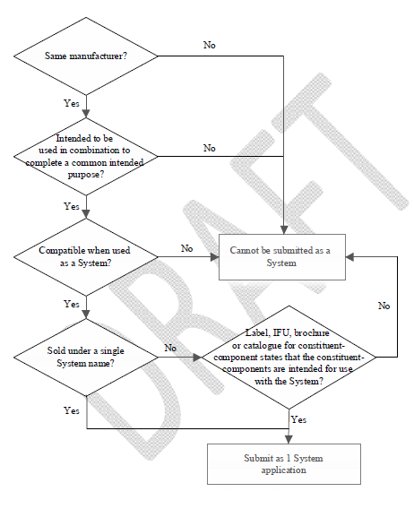

ANNEX 6: List of IVD Cluster Categories
This list of IVD CLUSTER categories is only applicable to Class A and Class B IVD. It should be clearly stated in the label or IFU of each reagent or article that it is intended for use, whether alone or in combination, for the same category:
S. No | Methodology | CLUSTER Category (closed list) | Examples of Analytes  (non-exhaustive list)
1 | Clinical Chemistry | Enzyme | (i) Acid Phosphatase  (ii) Alpha-Amylase  (iii) Creatine Kinase  (iv) Gamma-GlutamylTransferase  (v) Lactate Dehydrogenase  (vi) Lipase
2 | Clinical Chemistry | Substrate | (i) Albumin  (ii) Bilirubin  (iii) Urea/Blood Urea Nitrogen  (iv) Cholesterol  (v) Creatinine  (vi) Glucose
3 | Clinical Chemistry | Electrolyte reagents | (i) Ammonia  (ii) Bicarbonate  (iii) Calcium  (iv) Chloride  (v) Magnesium  (vi) Phosphate Inorganic/Phosphorus
4 | Clinical Chemistry | Electrolyte electrodes | (i) Ammonia Electrodes  (ii) Carbon Dioxide (Bicarbonate) Electrodes  (iii) Calcium Electrodes  (iv) Chloride Electrodes  (v) Magnesium Electrodes  (vi) Potassium Electrodes
5 |  | Substrate Electrodes/Biosensors | (i) Creatinine Electrodes  (ii) Glucose Electrodes  (iii) GlycatedHemoglobin Electrodes  (iv) Lactate Electrodes  (v) Urea Electrodes  (vi) Bilirubin Electrodes
6 | Immunochemistry | Immunoglobulins (without IgE). | (i) Immunoglobulin A  (ii) Immunoglobulin D  (iii) Immunoglobulin G  (iv) Immunoglobulin M  (v) Kappa and Lambda chain  (vi) Immunofixation kits
7 | Immunochemistry | Complement Components | (i) Complement Component C1q  (ii) Complement Component C1 inactivator  (iii) Complement Component C3/C3c  (iv) Complement Component for Bb  (v) Complement Component C4  (vi) Complement Component C5a
8 | Immunochemistry | Transport Protein | (i) Albumin  (ii) Ceruloplasmin  (iii) Haptoglobin  (iv) Hemopixin  (v) Lactoferrin  (vi) Pre-albumin/Transthyretin
9 | Immunochemistry | Lipoprotein | (i) Apolipoprotein A I  (ii) Apolipoprotein A II  (iii) Apolipoprotein B  (iv) Apolipoprotein E Sub-typing  (v) Lipoprotein (a)
10 | Immunochemistry | Other Specific Proteins | (i) a1-Acid Glycoprotein  (ii) a1-Antitrypsin  (iii) a2-Macroglobulin  (iv) a1-Microglobulin  (v) Fibronectin  (vi) Immuno Reactive Trypsin
11 | Immunochemistry | Alleregy | (i) Immunoglobulin E – Total  (ii) Immunoglobulin E – Screen  (iii) Immunoglobulin E – Specific, monotest/monoresult  (iv) Allergene specific IgA  (v) Allergene specific IgG
12 | Immunochemistry | Cancer markers | (i) BR-marker CA15-3  (ii) GI-marker CA19-9, CA242  (iii) Carcinoembryonic Antigen  (iv) Total Prostatic Specific Antigen  (v) Alphafetoprotein (AFP)  (vi) p53
13 | Immunochemistry | Thyroid Function Markers | (i) Free Triiodothyronine  (ii) Free Thyroxine  (iii) Thyroid Stimulating Hormone  (iv) T – Uptake  (v) Thyroglobulin  (vi) Neonatal Thyroxine
14 | Immunochemistry | Fertility/Pregnancy Hormones/ Proteins | (i) Androstenedione  (ii) Estradiol  (iii) Prolactin  (iv) Human Chorionic Gonadotropin Total  (v) Human Placental Lactogen  (vi) Estriol
15 | Immunochemistry | Diabetes Assays (Hormones) | (i) C-Peptide  (ii) Glucagon  (iii) Insulin  (iv)Glycosylated / Glycated Haemoglobin  (v) Islet Cell Ab  (vi) Proinsulin
16 | Immunochemistry | Renal metabolism assay | (i) Aldosterone  (ii) Angiotensin I / II  (iii) Angiotensin Converting Enzyme  (iv) Cortisol  (v) Renine
17 | Immunochemistry | Bone and Mineral Metabolism Assays | (i) Bone Alkaline Phosphatase  (ii) Calcitonin  (iii) Cross-linked C-Telopeptides  (iv) Cross-linkded N-Telopeptides  (v) Cyclic Adenosin Monophosphate  (vi) Hydroxyproline
18 | Immunochemistry | Endocrine Hormones and Peptides | (i) Adrenocorticotropic Hormone  (ii) Human Growth Hormone  (iii) Insulin-like Growth Factor I  (iv) Insulin-like Growth Factor Binding Protein 1  (v) Vasointestinal Peptide  (vi) Vasopressin
19 | Immunochemistry | Neuroendocrine Function Assays | (i) Bombesin  (ii) 17-Hydroxy-Ketosterone  (iii) β-Endorphin  (iv) Neurotensin  (v) Somatostatin  (vi) Substance P
20 | Immunochemistry | Other Individual and Specified Hormones | (i) Gastrin  (ii)Gonadotropin-Releasing Hormone  (iii) Melatonine  (iv) Pepsinogen  (v) Adrenalin  (vi) Dopamine
21 | Immunochemistry | Anaemia | (i) Erythropoietin  (ii) Ferritin  (iii) Folate  (iv) Iron  (v) Iron Binding Capacity  (vi) Soluble Transferrin Receptor
22 | Immunochemistry | Vitamins | (i) Vitamin B1  (ii) Vitamin B2  (iii) Vitamin B6  (iv) Vitamin B12  (v) Vitamin D (Cholecalciferol)  (vi)Intrinsic Factor (Blocking Antibody)
23 | Immunochemistry | Non-Immuno Suppressive Therapeutic Drug Monitoring | (i) Phenobarbitol  (ii) Digitoxin  (iii) Gentamicin  (iv) Valproic Acid  (v) Caffeine  (vi) Theophylline  (vii) Methotrexate
24 | Immunochemistry | Immunosuppressive Therapeutic Drug Monitoring | (i) Cyclosporine  (ii) Tacrolimus  (iii) Rapamycin (Sirolimus)  (iv) Mycophenolate
25 | Immunochemistry | Toxicology | (i) Amphetamines  (ii) Cocaine  (iii) Barbiturates  (iv) Morphines  (v) Phencyclidine  (vi) Acetaminophen  (vii) Catecholamines  (viii) Ethanol (ix) Salicylate
26 | Immunochemistry | Auto-immune Diseases | (i) Anti-nuclear antibodies (ANAs)  (ii) Anti-topoisomerase  (iii) Organ-specific autoantibodies  (iv) Circulating Immuno-complex  (v) TSH Receptor antibodies  (vi) Anti-Cardiolipin antibodies
27 | Immunochemistry | Rheumatoid-Inflammatory Diseases Markers | (i) Anti-Streptococcal Hyaluronidase  (ii) Anti-Streptokinase  (iii) Anti-Streptolysin O  (iv) C-Reactive Protein  (v) Anti-Staphylolysin  (vi) Anti-Streptococcal Screening
28 | Immunochemistry | Liver Function | (i) MEGX  (ii)Carbohydrate Deficient Transferrin
29 | Immunochemistry | Cardiac Markers | (i)BNP/proBNP  (ii) Creatine Kinase - MB  (iii) Myoglobin  (iv) Troponin I/T  (v) Homocysteine  (vi)High-Sensitivity C-Reactive Protein
30 | Immunochemistry | Bacterial Infection - Immunology | (i) Bacillus subtilis  (ii) Escherichia coli
31 | Immunochemistry | Viral Infection – Immunology | (i) Influenza virus
32 | Immunochemistry | Parasitic Infection - Immunology | (i) Entamoebahistolytica  (ii) Leishmania
33 | Immunochemistry | Fungal Infection - Immunology | (i) Candida albicans  (ii) Aspergillus
34 | Haematology  (Blood tests for transfusions excluded) | Hemoglobin testing | (i) Hemoglobin determinations (Total Hb)  (ii) Fractional oxyhemoglobin (FO2Hb)  (iii) Fractional carboxyhemoglobin (FCOHb)  (iv) Fractional methemoglobin (FMetHb)  (v) Fractional deoxyhemoglobin (FHHb)
35 | Haematology  (Blood tests for transfusions excluded) | General Coagulation tests | (i) Prothrombin Time  (ii) Thrombin Time  (iii) Activated Clotting Time  (iv) Activated Partial Thromboplastin Time
36 | Haematology  (Blood tests for transfusions excluded) | Haemostasis (Coagulation) | (i) Prothrombin  (ii) Thrombin  (iii) Fibrinogen  (iV)Protein C and Protein S reagents  (v) C1-inhibitors  (vi) Heparin  (vii) Alpha-Antiplasmin  (viii) Fibrin  (ix) Factor XIII  (x) Platelet Factor 4  (xi) Plasminogen
37 | Haematology  (Blood tests for transfusions excluded) | Other Hematology tests | (i) Complete Blood count  (ii) Hematocrit  (iii) Erythrocyte Sedimentation rate
38 | Histology/Cytology | Cytokines (Lymphokines)/ Immunomodulators | (i) Interferons  (ii) Soluble Antigens/Receptors  (iii) Tumor Necrosis Factors  (iv) Interleukins  (v) Colony Stimulating Factors  (vi) Tumor Necrosis Factors Receptors  (vii) Interleukins Receptors
39 | Histology/Cytology | Histology/ Cytology Reagents | (i) Cytochemical Staining  (ii) Embedding, Fixing, Mounting media  (iii) Stain solutions  (iv) Immunohistology kits
40 | Microbiology - culture (i) Cytochemical Staining (ii) Embedding, Fixing, Mounting media (iii) Stain solutions (iv) Immunohistology kits | Culture media | (i) Dehydrated culture media (DCM)  (ii) Additives for DCM  (iii) Prepared Media (Tubes, bottles, Plates)  (iv) Cells, Media, Serum for Viral culture
41 |  | Susceptibility testing  Identification of bacteria by testing for the susceptibility of the bacteria to the certain antibiotics. | (i) Erythromycin susceptibility test for Staphylococcus aureus  (ii) Tobramycin susceptibility test for Pseudomonas aeruginosa  (iii) Fungal susceptibility testing
42 |  | Biochemical culture Identification (ID) | (i) Gram Negative Manual ID  (ii) Gram Positive Manual ID  (iii) Other ID Kits Manual - Anaerobes, Fastidious  (iv) Mycoplasma
43 |  | Immunological culture Identification (ID) | (i) Streptococci Grouping Slide tests  (ii) Serotyping (E.coli, Salmonella, Shigella etc.)
44 |  | Nucleic Acid (NA) based culture identification (ID) | (i) NA Identification – MRSA  (ii) NA Identification – Other resistance markers
45 |  | Serological identification (ID) | (i) For Parasitology and Mycology (Fungi and Yeast)
46 | Molecular Biology | Oncogenes  Genes, whose mutation or enhanced expression, turns a normal cell into a cancer cell. | (i) p53  (ii) MYC (8q24)  (iii) TERC (3q26)
47 | Molecular Biology | Bacterial Infections (Detection by NA Reagents) | (i) Staphylococcal detection  (ii) E.coli detection
48 | Molecular Biology | Viral Infections (Detection by NA Reagents) | (i) Influenza and Para-influenza NA Reagents
49 | Molecular Biology | Fungal Infections | (i) Fungi NA Reagents

ANNEX 7: Decision Flowchart for Grouping of Products as An IVD Cluster

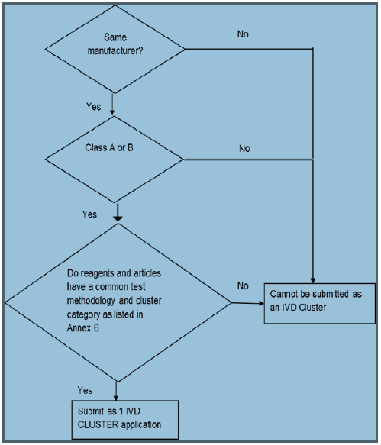

ANNEX-6:

6.1. DEVICE SPECIFIC GROUPING OF CLASS I OR CLASS II DENTAL MEDICAL DEVICES USING DENTAL GROUPING TERMS

Dental Grouping Terms (DGT) are collective generic terms used to describe a group of similar Class I and Class II dental medical devices with a common intended purpose.

A DGT grouping of dental medical devices is a collection of dental devices and each individual device:

- is from the same product owner ;

- is of the same risk classification (either Class I only or Class II only); and

- intended purpose falls within the descriptor of one DGT.

The product registration application may contain accessories of a lower risk class if they are specifically intended to be used together with the dental devices submitted under a DGT.

For Class I only or Class II only (where applicable, with accessories) dental medical devices, the applicant may choose to group their dental devices using the general grouping criteria described in General Grouping Criteria or this device specific grouping criteria using the DGT for product registration. DGT is not applicable to Class III and Class IV dental medical devices.

 |  |  | Dental medical devices
 | Class I only or Class II only devices |  |  |  |  | Class C or Class D
 | Device Specific |  | Grouping as per
 | Grouping Criteria for |  |  |  |  | Grouping as per
 |  |  | GENERAL GROUPING CRITERIA Guidance
 | Class A and B |  |  |  |  | GENERAL GROUPING CRITERIA Guidance
 |  |  | document
 | dental devices - |  |  |  |  | document

DGT

Figure 1 Dental medical device grouping consideration

When dental devices satisfy the above conditions to be grouped in one DGT application, the device name listed on the ERIS upon approval will be based on the dental grouping term used. The descriptor of the DGT will be used as the description of intended use on ERIS. The individual models will be listed on the ERIS as per product name (device label) under the section “Model Info”.

6.1.1. LIST OF DENTAL GROUPING TERMS (DGT) AND RESPECTIVE DESCRIPTORS

The list of DGT and respective descriptors are only applicable to Class I only and Class II only dental devices.

 | No | DGT | Descriptor
 | 1. | Adhesive kit for | A kit/pack that contains a collection of devices intended to
 |  | dental composite | be used to bond attachments such as hooks or buttons to
 |  |  | the teeth and/or to an orthodontic aligner during dental or
 |  |  | orthodontic teeth adjustment.
 | 2. | Cryoanaesthesia | A dental brace-like device that is chilled to
 |  | device, dental | freezing/subfreezing temperatures and then applied to the
 |  |  | labial sulci (gums) in a patient's mouth for a period to
 |  |  | provide a cold anaesthesia for the underlying nerves. This
 |  |  | device may be used as a substitute for hypodermic drug
 |  |  | delivery during dental procedures.
 | 3. | Cryogenic spray, | A refrigerant use to cool down a tooth by spraying on it,
 |  | dental | mainly to find out if the pulp is vital. It can also be used as
 |  |  | a local anaesthetic when extracting deciduous teeth in
 |  |  | children.
 | 4. | Cusps, dental | A device designed to provide an artificial projection on the
 |  |  | chewing surface of the tooth to achieve a proper bite
 | 5. | Dental abrasives | A dental material which can be applied with an appropriate
 |  |  | device to the surface of teeth or dental devices for
 |  |  | prophylactic and/or treatment applications. This includes
 |  |  | removal of plaque and stains, cleaning fissures (above and
 |  |  | below the gingiva), the preparation of a tooth surface prior
 |  |  | to bonding, the cleaning of orthodontic appliances (bands
 |  |  | and brackets), the removal of adhesive residue, and the
 |  |  | cleaning of implants prior to loading. It may include
 |  |  | accessories required for dental abrasion.
 | 6. | Dental absorbent | Non medicated device intended to be used to absorb fluids
 |  |  | during dental procedures.
 | 7. | Dental adhesives/ | A material used as a bonding promoting substance
 |  | primers | between dental materials. It does not include cements.
 | 8. | Dental broach | A device that is designed with an abrasive outer surface to
 |  |  | cut, open, enlarge, resurface with precision holes in hard
 |  |  | tissues (e.g. bones, root canals), extirpating pulp and/or for
 |  |  | exploring the root canal.

 | No | DGT |  | Descriptor
 | 9. | Dental burs |  | A rotary cutting device designed to fit into a dental
 |  |  |  | handpiece and intended to cut hard structures in the mouth,
 |  |  |  | e.g. teeth or bone.
 | 10. | Dental caries |  | A device designed to measure resistance to the flow of
 |  | detector, electrical |  | electric current across teeth for the diagnosis of early stage
 |  | impedance |  | dental caries and/or to monitor the progress of caries
 |  |  |  | (carious areas being less resistant due to higher
 |  |  |  | concentrations of fluid).
 | 11. | Dental caries |  | A device designed to determine the changes in the
 |  | detector, optical |  | fluorescence of teeth enamel and dentine due to mineral
 |  | induced |  | loss, mainly for the diagnosis of early stage dental caries
 |  | fluorescence |  | and/or to monitor the progress of caries
 | 12. | Dental caries |  | A substance used to detect and remove caries from an
 |  | removal solution |  | infected tooth.
 | 13. | Dental casting |  | Compounds associated with the formation of a dental cast,
 |  | materials |  | i.e. a positive copy of a part of the oral anatomy made in an
 |  |  |  | impression (mould).
 | 14. | Dental cavity liner |  | A substance intended to be applied to the interior of a
 |  |  |  | prepared cavity before insertion of restorative material, to
 |  |  |  | protect the pulp of a tooth from chemical irritation.
 | 15. | Dental cement |  | Compounds used to bond a dental prosthesis to the
 |  |  |  | anatomy (luting agent), to form an insulating layer under
 |  |  |  | dental restorations. It may include accessories to complete
 |  |  |  | the cementing procedure.
 | 16. | Dental cement kit |  | A kit/pack that contains a collection of components
 |  |  |  | designed to complete a cementing procedure.
 | 17. | Dental crowns/ |  | A material used to manufacture partial or full crowns and
 |  | bridges |  | bridges.
 | 18. | Dental |  | A substance that destroys harmful microorganisms or
 |  | disinfectants |  | inhibit their activity on medical devices which are specific
 |  |  |  | for dental purposes or for use in dental procedures. It is not
 |  |  |  | intended for disinfection as end point of processing.
 | 19. | Dental dry field |  | A device used in orthodontic and restorative dentistry to
 |  | device |  | maintain a dry oral cavity for treatment procedures. It forms
 |  |  |  | a frame around the oral cavity and provides the operator
 |  |  |  | with easy access to the field of operation by holding the
 |  |  |  | mouth open, displacing the tongue, and removing saliva
 |  |  |  | during various procedures

 | No | DGT | Descriptor
 | 20. | Dental dry field kit | A kit/pack that contains a collection of devices used in
 |  |  | orthodontic and restorative dentistry to maintain a dry oral
 |  |  | cavity for treatment procedures. It provides the operator
 |  |  | with easy access to the field of operation by holding the
 |  |  | mouth open, displacing the tongue, and removing saliva
 |  |  | during various procedures.
 | 21. | Dental etching | A device used to create a retentive surface for a composite,
 |  | composite | an adhesive or a pit and fissure sealant.
 | 22. | Dental file | A device that is intended for smoothing, filing or cutting
 |  |  | during dental procedure and typically have various forms of
 |  |  | fine-ridged cutting surfaces along part or all of their working
 |  |  | length. This device may be used to remove gross
 |  |  | supragingival calculus, smooth the cementoenamel
 |  |  | junction (CEJ), finish the margins of the teeth or other
 |  |  | dental restorations or enlarge the root canal.
 | 23. | Dental implant | A rotary dental instrument designed for the debridement of
 |  | debridement | a patient's dental implants affected by peri-implantitis.
 |  | brush
 | 24. | Dental implant | A device used to retrieve a dental implant from the oral
 |  | extractor | cavity.
 | 25. | Dental implant, | Device designed to provide support and a means of
 |  | accessories | retention for a dental prosthesis during surgical placement
 |  |  | of a dental implant into alveolar and/ or basal bone of the
 |  |  | mandible or maxilla.
 | 26. | Dental implant, | A small rod that bears prosthetic teeth and allows them to
 |  | prosthetic teeth | be attached to the dental implant abutments.
 |  | bar
 | 27. | Dental implant, | A prefabricated device that is incorporated into, or creates,
 |  | suprastructure | a suprastructure on dental implants to mimic preparations
 |  |  | of natural teeth.
 | 28. | Dental | A kit/pack that contains a collection of various dental
 |  | implant/prosthesis | instruments designed for the surgical placement of dental
 |  | , surgical | implants or prostheses. It does not contain
 |  | procedure kit | pharmaceuticals.
 | 29. | Dental precision | Dental device designed for attaching a fixed or removable
 |  | attachments | prosthesis to the crown of an abutment tooth, dental
 |  |  | restoration (including implants), or dental appliance.

 | No | DGT | Descriptor
 | 30. | Dental procedure | An assembly of devices designed to bore/ excavate bones,
 |  | console and | teeth, and tough tissues during a dental surgical procedure.
 |  | accessories, | The system is powered by pressurized water via a
 |  | hydraulic | connecting hose to the handpiece/motor water-driven
 |  |  | turbine.
 | 31. | Dental procedure | An assembly of devices designed to bore/ excavate bones,
 |  | console and | teeth, and tough tissues during a dental surgical procedure.
 |  | accessories, line- | This system is electrically-powered and supplies the
 |  | powered | handpiece/motor with low-voltage electricity through a
 |  |  | control unit.
 | 32. | Dental procedure | An assembly of devices designed to bore/excavate bones,
 |  | console and | teeth, and tough tissues during a dental surgical procedure.
 |  | accessories, | The system is pneumatically-powered.
 |  | pneumatic
 | 33. | Dental procedure | A hand-held dental device that includes a chuck for
 |  | handpiece, | attaching dental drills, burs, reamers, and similar rotating
 |  | hydraulic | instruments used to bore/excavate bones, teeth, and tough
 |  |  | tissues in dentistry. The device is driven by a source of
 |  |  | pressurized water.
 | 34. | Dental procedure | A hand-held dental device that includes a chuck or collet
 |  | handpiece, line- | for attaching a dental drill, bur, reamer, and other similar
 |  | powered | rotating instruments used to bore/excavate bones, teeth,
 |  |  | and tough tissues in dentistry. It is powered by a low-
 |  |  | voltage electric micro-motor that is an integral part of the
 |  |  | device.
 | 35. | Dental procedure | A hand-held dental device that includes a chuck for
 |  | handpiece, | attaching dental drills, burs, reamers, and similar rotating
 |  | pneumatic | instruments used to bore/excavate bones, teeth, and tough
 |  |  | tissues in dentistry. It is pneumatically-powered.
 | 36. | Dental pulp | A device intended to be applied to the surface of a tooth
 |  | testing electrode | before use of a pulp tester to aid conduction of electrical
 |  | gel | current.
 | 37. | Dental pulp- | A dental compound designed to cover an exposed or
 |  | capping material | nearly-exposed dental pulp (e.g., due to deep cavities) to
 |  |  | provide protection against external influences and to
 |  |  | promote healing. This compound does not have dental
 |  |  | cement or dental cavity liner intended uses.
 | 38. | Dental reamer | A device that is designed with fine-toothed cutting edges to
 |  |  | cut, open, enlarge openings in, and/or resurface hard
 |  |  | tissues (e.g. bones, root canals) with precision.

 | No | DGT | Descriptor
 | 39. | Dental reinforcing | A device used in general restorative dentistry and
 |  | fibre | orthodontic treatment as reinforcement of dental materials,
 |  |  | used for the construction of dental prostheses. It may also
 |  |  | be used for the stabilization of avulsed teeth maintaining
 |  |  | diastema closures or split-tooth syndrome.
 | 40. | Dental restorative | A substance used to cover dental filling material in the initial
 |  | / cavity varnish | setting period after application typically to prevent moisture
 |  |  | infiltration for the protection of pulpal tissue and to provide
 |  |  | a marginal seal to newly placed amalgam restorations.
 | 41. | Dental restorative | A substance intended to fill dental cavities, seal pits and
 |  | / repair materials | fissures, restore damaged dental tissues, or for inlays,
 |  |  | onlays and veneering. It may include accessories that are
 |  |  | used specifically with the materials. It does not include
 |  |  | obturation of root canal.
 | 42. | Dental restorative/ | A kit/pack that contains a collection of devices designed to
 |  | repair kit | fill dental cavities, seal pits and fissures, restore damaged
 |  |  | dental tissues, or for inlays, onlays and veneering. It does
 |  |  | not include obturation of root canal.
 | 43. | Dental retention | A device intended to be placed permanently in the tooth to
 |  | pin | provide retention and/or stabilization of dental restorations,
 |  |  | e.g. fillings or crowns.
 | 44. | Dental retention | A kit/pack that contains a collection of devices intended for
 |  | pin kit | the insertion of permanent pins in healthy dentin to provide
 |  |  | retention and/or stabilization of dental restorations, e.g.
 |  |  | fillings and crowns.
 | 45. | Dental scalers, | Scaler tip/inserts which may consist of handpieces that are
 |  | pneumatic | designed to use compressed air to generate a vibrating
 |  |  | action at its point of patient contact for the removal of
 |  |  | accretions from tooth surfaces during dental cleaning or
 |  |  | periodontal (gum) therapy.
 | 46. | Dental scalers, | Scaler tip/inserts which may consist of handpieces that
 |  | rotary | provides rotation and is used to remove calculus deposits
 |  |  | and other accretions from tooth surfaces during dental
 |  |  | cleaning and periodontal (gum) therapy.
 | 47. | Dental scalers, | Scaler tip/inserts (which function as part of an ultrasonic
 |  | ultrasonic | scaler system) which may consist of handpieces that
 |  |  | together transmit ultrasonic energy from a generator to the
 |  |  | oral cavity for the removal of accretions from tooth surfaces
 |  |  | during dental cleaning or periodontal (gum) therapy.

 | No | DGT | Descriptor
 | 48. | Dental scaling | An assembly of devices designed to use compressed air to
 |  | system, | generate a vibrating action at its point of patient contact for
 |  | pneumatic | the removal of accretions from tooth surfaces during dental
 |  |  | cleaning or periodontal (gum) therapy. The handpiece may
 |  |  | connect to an existing air driven handpiece tubing and the
 |  |  | water spray for lavage. This device is used for procedures
 |  |  | that may involve the removal of plaque, biofilm, or gross
 |  |  | calculus from shallow to deep periodontal pockets. It can
 |  |  | be also used for the removal of orthodontic cement.
 | 49. | Dental scaling | An assembly of powered dental handpiece that provides
 |  | system, rotary | rotation and is used to remove calculus deposits and other
 |  |  | accretions from tooth surfaces during dental cleaning and
 |  |  | periodontal (gum) therapy. This device is used for
 |  |  | procedures that may involve the removal of plaque, biofilm,
 |  |  | or gross calculus from shallow to deep periodontal pockets.
 |  |  | It can be also used for the removal of orthodontic cement.
 | 50. | Dental scaling | An assembly of devices that uses ultrasonic energy at its
 |  | system, ultrasonic | point of patient contact to remove accretions from tooth
 |  |  | surfaces during dental cleaning or periodontal (gum)
 |  |  | therapy. This device is used for procedures that may
 |  |  | involve the removal of plaque, biofilm, or gross calculus
 |  |  | from shallow to deep periodontal pockets. It can be also
 |  |  | used for the removal of orthodontic cement.
 | 51. | Dental sealants, | A substance used in endodontics to fill or permanently
 |  | endodontic | obturate the root canal of a tooth. The substance may be
 |  |  | intended for orthograde use (i.e., a root filling placed from
 |  |  | the coronal aspect).
 | 52. | Dental sealants, | A material intended for sealing pits and fissures on teeth. It
 |  | pit/fissure | may include accessories to complete the sealing
 |  |  | procedure.
 | 53. | Dental shaded | A kit/pack that contains a collection of devices intended to
 |  | pontic kit | be used to produce artificial tooth veneers (shaded pontics)
 |  |  | typically inside clear plastic custom-made teeth aligners
 |  |  | (retainer-style orthodontic appliances). This is used to
 |  |  | create the appearance of teeth inside the aligner to cover
 |  |  | spaces where teeth may be missing for aesthetic and/or
 |  |  | therapeutic purposes during treatment to realign teeth.
 | 54. | Dental solution, | A substance used to soften and partially solubilize a dental
 |  | scaling | calculus (a hard deposit that forms on the teeth) before
 |  |  | scaling mechanically so that less force is required,
 |  |  | especially when teeth are loose.

 | No | DGT | Descriptor
 | 55. | Denture base | A material used for the fabrication of a denture base or
 |  | resins | repair of a denture.
 | 56. | Denture clasps | Dental devices designed to retain and stabilize removable
 |  |  | partial dentures to stationary teeth.
 | 57. | Denture reliners | A device that is applied as a permanent coating or lining on
 |  |  | the base or tissue-contacting surface of a denture to
 |  |  | provide a new fitting surface to a denture.
 | 58. | Dental suction | A component of a dental suction system designed to be
 |  | system cannula | inserted into the oral cavity for the aspiration and removal
 |  |  | of blood, pus, saliva, debris, and water during a dental
 |  |  | procedure.
 | 59. | Facebow | A caliper-like dental instrument used to record the relative
 |  |  | position of the maxillary arch to the temporo-mandibular
 |  |  | joint (TMJ), or the opening axis of the jaw. It is used to
 |  |  | orient dental casts in the same relationship to the opening
 |  |  | axis of the articulator.
 | 60. | Fixture/appliance | A device intended to be used in dental surgery to create
 |  | dental drill | channels of appropriate depth and diameter in bone
 |  |  | (osteotomy) of the oral cavity to facilitate the implantation
 |  |  | of a dental fixture/appliance. It is attached to a motorized
 |  |  | handpiece or other power source that provides rotation.
 | 61. | Gingiva bleaching | A substance designed to protect a patient's gums from the
 |  | protector | hydrogen peroxide found in teeth whitening agents used
 |  |  | during chairside light-curing bleaching of the teeth.
 | 62. | Gingival retraction | A non-medicated device used to temporarily hold off the
 |  | cord, non- | gingiva during abutment preparation.
 |  | medicated
 | 63. | Gingival retraction | A kit/pack that contains collection of devices used to
 |  | kit | temporarily hold off the gingiva during abutment
 |  |  | preparation.
 | 64. | Gingival retraction | A substance used in dentistry to induce gingival retraction
 |  | solution | by in situ impregnation of a non-medicated gingival
 |  |  | retraction cord. It induces contraction of the upper strata of
 |  |  | the free gingiva. This device may also induce a local stasis
 |  |  | of gingival exudates and gingival haemorrhages.
 | 65. | Non-medicated | A kit/pack that contains a collection of dental instruments,
 |  | dental surgical | dressings and the necessary materials used to perform a
 |  | procedure kit, | dental surgical procedure. It does not contain any
 |  |  | pharmaceuticals.

 | No | DGT | Descriptor
 | 66. | Oral wound | A device intended as a protective cover for the oral mucosa
 |  | dressing | to manage wounds and sores in the mouth. It is used for
 |  |  | various types of dental wounds, sores and lesions caused
 |  |  | by dental prostheses/orthodontic braces; it may also be
 |  |  | used to treat mucosal irritations/inflammation, dryness and
 |  |  | gingivitis. This does not include pharmaceuticals.
 | 67. | Orthodontic | A device used in orthodontic dentistry to intra-orally chill or
 |  | appliance | cool thermally-activated archwires when placing bends in
 |  | archwire-cooling | an orthodontic appliance.
 |  | device
 | 68. | Orthodontic | Dental devices designed to influence the shape and/or
 |  | appliances | function of the stomatognathic system through the
 |  |  | application of physical force.
 | 69. | Orthodontic space | A dental prosthetic replacement for prematurely lost
 |  | maintainer | deciduous teeth intended to prevent closure of the space
 |  |  | before eruption of the permanent successors.
 | 70. | Periodontal | A material which is placed over the periodontal tissues as
 |  | dressing | a dressing, normally after surgery. This does not include
 |  |  | pharmaceuticals.
 | 71. | Root canal filling- | A substance used in endodontic procedures for the
 |  | removal solution | softening and removal of root canal fillings.
 | 72. | Root canal | A substance used to facilitate cleansing/irrigation of the
 |  | irrigation/ rinsing | root canal (the canal space) during and/or after endodontic
 |  | solution | instrumentation for the removal of the smear layer, pulpal
 |  |  | tissue, necrotic materials, and bacteria from the
 |  |  | instrumented root canal, before placement of the
 |  |  | endodontic filling.
 | 73. | Root canal | A kit/pack that contains a collection of devices designed to
 |  | obturation kit | permanently prime, seal, and/or fill a tooth undergoing a
 |  |  | root canal procedure.
 | 74. | Root canal post | A kit/pack that contains collection of root canal posts and
 |  | kit | devices used for the insertion of root canal posts.
 | 75. | Root canal posts | A device intended to be inserted and cemented into a
 |  |  | prepared root canal of a tooth to stabilize and support a
 |  |  | restoration.
 | 76. | Root canal | A kit/pack that contains a collection of dental devices
 |  | preparation kit | designed to be used in root canal preparation.

 | No | DGT | Descriptor
 | 77. | Root surface | A material used for topical application on exposed/scaled
 |  | conditioner | root surfaces for the removal of the smear layer during
 |  |  | dental/periodontal surgery. The material is removed after
 |  |  | the recommended period to expose the collagenous matrix
 |  |  | of dentine surfaces.
 | 78. | Tooth | A kit/pack that contains a collection of devices designed to
 |  | preservation kit | preserve and transport a tooth that has been knocked out
 |  |  | (i.e., avulsed) so it can be reimplanted. It is used to avoid
 |  |  | tooth cell crushing and/or dehydration by immersing the
 |  |  | tooth in a pH balanced solution compatible with periodontal
 |  |  | cells, and is used in field emergency situations after
 |  |  | traumatic knock out of teeth.
 | 79. | Warm-bonded | Devices designed to deliver preheated sealing, filling, and
 |  | endodontic | core materials into a root canal for direct warm bonding
 |  | obturation system | during an endodontic obturation procedure.

Decision Flowchart for Grouping of Dental Medical Devices using Dental

Grouping Terms (DGT)
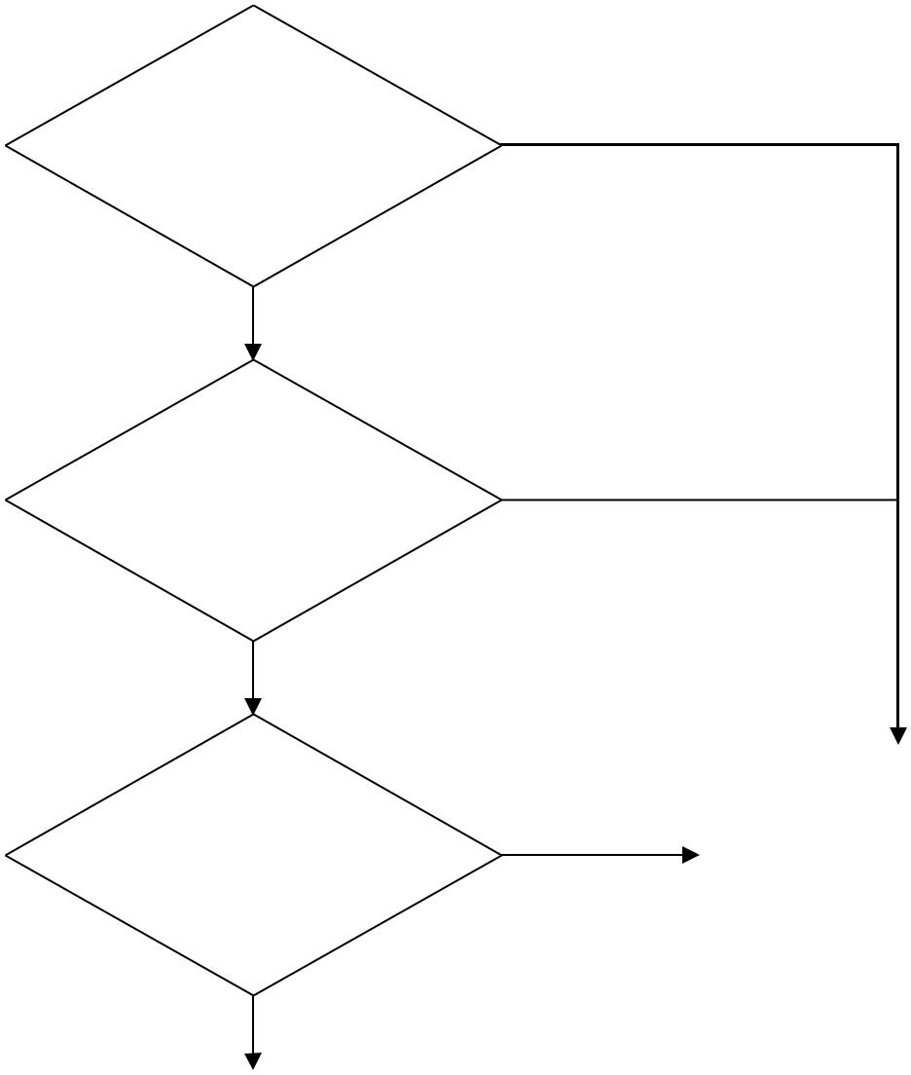

From same Product | No
Owner?

Yes

Same risk |  | No
classification (either
Class I only or
Class II only)?
Yes
 |  |  | Cannot be submitted as
Falls within the | No |  | one DGT application;
Falls within the | No |  | refer to GENERAL GROUPING CRITERIA
descriptor of one |  |  | refer to GENERAL GROUPING CRITERIA
descriptor of one |  |  | guidance document for
DGT? |  |  | guidance document for
DGT? |  |  | other grouping options
Yes
Can be submitted as
one DGT application

The following examples provide a comparison between the grouping of dental medical devices using the general grouping criteria in General Grouping Criteria and using the device specific grouping - DGT.

Example:

Product Owner “EFDA Zen” manufactures 3 different dental cements of different cement materials as follows:
 | Product name |  | Description
EFDA Zen 1 dental cement |  |  | Main Constituent: Zinc Phosphate
 |  |  | Available as 2g and 4g syringes
EFDA Zen 2 dental cement |  |  | Main Constituent: Polycarboxylate
 |  |  | Available as 2g syringe and 2g kit (dispenser,
 |  |  | mixing pad)
EFDA Zen 3 dental cement |  |  | Main Constituent: Glass Ionomer
 |  |  | Available as 2g and 4g syringes

Using the general grouping criteria in GENERAL GROUPING CRITERIA

Based on general grouping criteria in General Grouping Criteria, these 3 products cannot be grouped together as a FAMILY because of the different product material which does not qualify as having a common design and manufacturing process.

Using device specific grouping - DGT

In order to submit a product registration using the device specific grouping criteria in DEVICE SPECIFIC GROUPING CRITERIA guidance document - DGT, the applicant has to determine if the dental medical devices fulfill the DGT requirements:
From the same product |  | Yes (“EFDA Zen” is the common product owner)
owner
Within the risk |  | Yes (all cement products are Class II medical devices)
classification of Class I
only or Class II only?
Falls within the |  | Yes; all 3 products fall under the DGT of :
descriptor of one DGT |  | DGT - Dental Cement
 |  | Descriptor for Dental Cement:
 |  | Compounds used to bond a dental prosthesis to the anatomy
 |  | (luting agent), to form an insulating layer under dental
 |  | restorations. It may include accessories to complete the
 |  | cementing procedure.

Therefore, these 3 Class B dental cements, which are different in design and manufacturing process, can be grouped together in one application using the DGT “Dental Cement”. Devices will be listed on ERIS as “EFDA Zen Dental Cement”.

  - DEVICE SPECIFIC GROUPING OF HEARING AIDS

This section applies only to Class II hearing aids and excludes implantable hearing devices.

Generally, hearing aids can be categorized based on:

- Design (i.e Behind the ear (BTE) vs In the ear (ITE) (e.g. ITE devices have all components of the hearing aids are contained in tiny case shell that fits in the ear or canal))

- Technology for sound amplification (i.e. analogue vs digital)

- Communication technology (i.e Wireless vs Non-wireless communication)

A device specific grouping of hearing aids comprises of a collection of hearing aids that are:

- from the same product owner;

- within risk classification Class II only (hearing aids not including the implantable hearing devices);

- have the same design type (i.e. behind the ear or in the ear);

- have the same technology for sound amplification (i.e. analogue or digital); and

- have the same communication technology (i.e. wireless or non-wireless).

The product registration application may contain accessories of a lower risk class if they are specifically intended to be used together with the hearing aids.

For Class II only hearing aids, the applicant may choose to group their devices using the general grouping criteria described in General Grouping Criteria

or this device specific grouping criteria for hearing aids. This device specific grouping criteria for hearing aids would not be applicable for Class III and Class IV medical devices (e.g. cochlear implant systems), as well as Class II hearing devices that are used in conjunction as part of an implantable hearing system (e.g. sound processors of a bone-anchored hearing system).

Hearing Aids

Class II Hearing Aids |  |  |  |  | Class III or Class IV
Device specific |  | Grouping as per |  |  | Grouping as per
Grouping Criteria for |  | GENERAL GROUPING CRITERIA Guidance |  |  | GENERAL GROUPING CRITERIA Guidance
Hearing Aids |  | document |  |  | document


Figure 2 Hearing Aid grouping consideration

When hearing aids satisfy the above conditions to be grouped in one device specific hearing aid grouping application, but have different device proprietary names or brand names, the devices will be listed separately on the ERIS based on their proprietary names upon approval of the application.

Decision Flowchart for Grouping of Hearing Aids
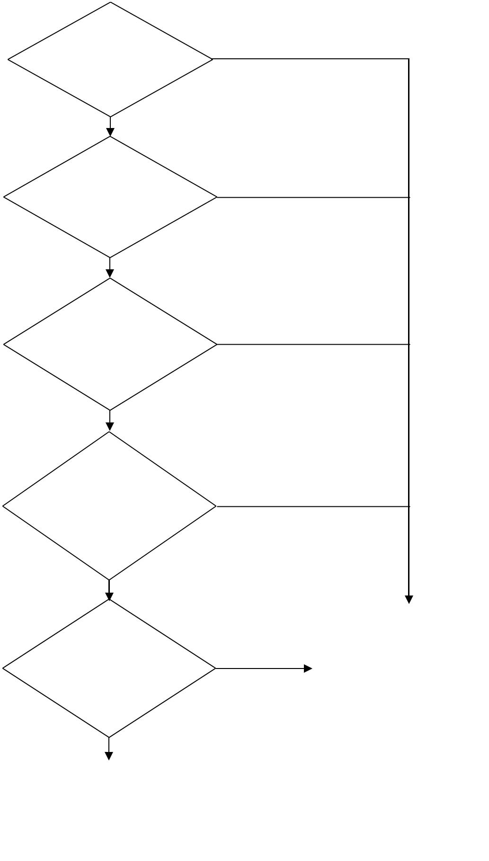

From same

Product Owner?

Yes

Within the risk
classification of
Class II only?

Yes

Have same
design type (in
the ear or behind

the ear)?

Yes

Have same
technology for sound
amplification
(analogue or

digital)?

Yes

No

No

No

No

 |  | Have same |  | Cannot be submitted
 |  | Have same |  | as one device
 | communication |  | No | as one device
 |  |  | No | specific grouping
technology (wireless |  |  | No | specific grouping
 |  |  |  | application; refer to
 | or non-wireless)? |  |  | application; refer to
 |  |  |  | GENERAL GROUPING CRITERIA guidance
 |  |  |  | document for other
 | Yes |  |  | grouping options
Can be submitted as one
device specific grouping
application for hearing aids

The following example clarifies the possible grouping combinations using the Device Specific Grouping of Hearing Aids.

Example:

Product Owner “EFDA Zen” manufactures a collection of Class II hearing aids, they:

- have the same design type – all are in the ear design

- have the same technology for sound amplification - digital

- comes in two variants in communication technology – using wireless and non-wireless technology

Table 1 Grouping consideration using the Device Specific Grouping of Hearing Aids for this example
DEVICE SPECIFIC GROUPING CRITERIA |  | Behind the Ear |  |  |  |  | In the Ear
Grouping
Grouping |  | Analogue |  | Digital |  |  | Analogue |  | Digital
Criteria |  | Analogue |  |  |  |  | Analogue |  | Digital
Wireless |  | ✗ |  | ✗ |  |  | ✗ |  | ✓
Non-wireless |  | ✗ |  | ✗ |  |  | ✗ |  | ✓

Using Device Specific Grouping of Hearing Aids

Based, on the tabulated consideration, the hearing aids, which differ in the communication technology criteria, they cannot be grouped together in a single application. Hence, two product registration applications have to be submitted separately.

- EFDA Zen hearing aids (non-wireless), and

- EFDA Zen hearing aids (wireless).

  - DEVICE SPECIFIC GROUPING OF IMMUNOHISTOCHEMISTRY IN VITRO DIAGNOSTIC REAGENTS

Immunohistochemistry (IHC) IVD reagents are in vitro diagnostic (IVD) products consisting of polyclonal or monoclonal antibodies labelled with directions for use and performance claims, which may be packaged with ancillary reagents in kits. Their intended use is to identify, by immunological techniques, antigens in tissues or cytologic specimens, and excludes reagents specifically intend to be used with flow cytometry. This section applies to IHC IVD reagents and their accessories only.

A device specific IHC IVD grouping category comprises of a collection of IVD reagents and their accessories that are:

- from the same product owner;

- is of the same risk classification (either Class B only or Class C only);

- based on IHC methodology; and

- within the same IHC IVD Grouping Category as listed below.

When IHC IVD reagents and their accessories satisfy the criteria to be grouped under one of the six prescribed IHC IVD grouping categories, they can be grouped together and submitted in one product registration application. In cases where the IHC IVD reagents have different device proprietary names, they may be grouped together during the product registration submission. However, the products will be listed separately on the ERIS based on their proprietary names.

The device name listed on the ERIS upon approval will be based on the proprietary name and the IHC IVD grouping category used during product registration. The individual models will be listed on the ERIS as per product name (device label) under the section “Model Info”. Alternatively, product owners and applicants may choose to group these devices using the general grouping criteria described in General Grouping Criteria.

If any reagent and its accessories are intended for multiple usage categories such that it can be grouped in more than one IHC IVD grouping category, the applicant can choose to group the reagents and their accessories as part of any one of the IHC IVD categories it qualifies. Information to support the intended purposes of all the reagents and their accessories must be submitted as part of the product registration application.

    - LIST OF IHC IVD GROUPING CATEGORIES

The list of IHC IVD categories for the device specific grouping of Class B only or Class C only IHC reagents and their accessories is a closed and positive list.

S/N | IHC IVD Grouping | Examples of Analytes
 | Category (closed list) | (non-exhaustive list)
1 | Selective Therapy | (i) | HER2/neu
 |  | (ii) | EGFR
2 | Hematologic Disorder and | (i) | Immunoglobulin Kappa chain
 | Blood Cancer Markers | (ii) | Immunoglobulin Lambda chain
3 | Other Cancer Markers | (i) | Alpha fetoprotein (AFP)
 |  | (ii) | Cytokeratins
 |  | (iii) | CD117
4 | Pathogen Markers | (i) | Escherichia coli
 |  | (ii) | Candida albicans
 |  | (iii) | Herpes simplex virus protein VP22
5 | Immune Disorders | (i) | Anti-nuclear antibodies (ANAs)
 |  | (ii) | Anti-topoisomerase
 |  | (iii) | Organ-specific autoantibodies
 |  | (iv) | Anti-Streptococcal Hyaluronidase
 |  | (v) | Anti-Streptokinase
 |  | (vi) | Anti-Streptolysin O
 |  | (vii) | C-Reactive Protein
6 | Other Pathology Markers | (i) | P57
 |  | (ii) | Growth hormone

Decision Flowchart for Grouping of Class B only or Class C only IHC IVD

Grouping Category
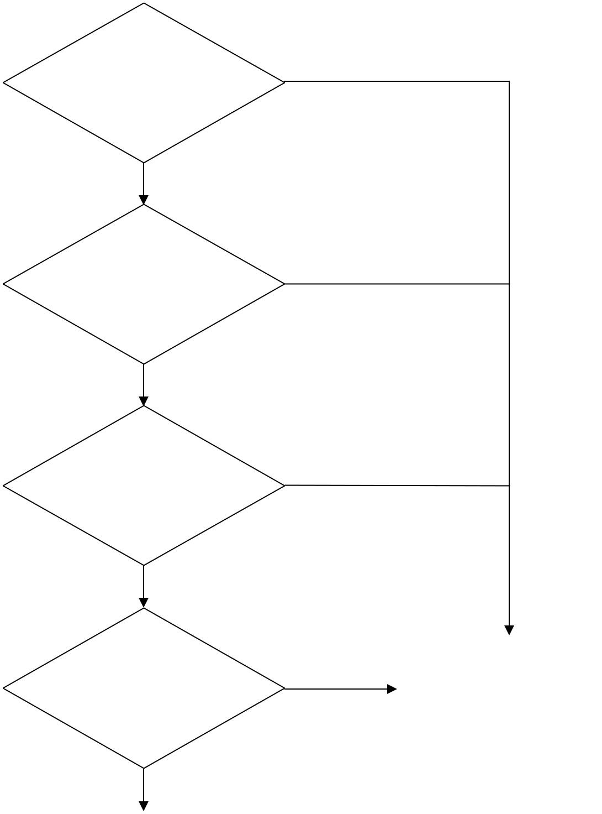

From same Product
Owner?

No

Yes

Same risk
classification (either ^{No}
Class B only or

Class C only)?

Yes

Based on IHC

methodology?

No

Yes

Falls within the same | No | Cannot be submitted
Falls within the same | No | as one IHC IVD
listed IHC IVD |  | application; refer to
Category? |  | application; refer to
Category? |  | GENERAL GROUPING CRITERIA guidance
 |  | document for other
Yes |  | grouping options
Can be submitted as
one IHC IVD category
application

Examples:

Product Owner is “EFDA”

1 Class B IHC IVD category

(e.g. Immune Disorders)

EFDA ABC Antibody |  |  | EFDA ABC Antibody |  |  |  |  | EFDA XYZ Antibody |  |  |  | EFDA XYZ Antibody
for immunological |  |  | for immunological |  |  |  |  | for immunological |  |  |  | for immunological
marker A |  |  | marker B |  |  |  |  | marker C |  |  |  | marker D

Figure 3 Example of a Class B IHC IVD grouping category with 4 products within the category

Based on the example provided in Figure 3, the 4 IHC IVD products qualify for submission as one IHC IVD grouping category of “Immune Disorders” and would be listed as 2 ERIS listings based on their proprietary names:

- EFDA ABC Immunohistochemistry Antibody (Immune Disorders)*

- EFDA XYZ Immunohistochemistry Antibody (Immune Disorders)**

- EFDA ABC Antibody for immunological markers A and B are under one listing in which EFDA is the product owner and ABC is the proprietary name.

- EFDA XYZ Antibody for immunological markers C and D are under one listing in which EFDA is the product owner and XYZ is the proprietary name.

Examples:

Product Owner is “EFDA”

1 Class C IHC IVD category

(e.g. Pathogen Markers)

EFDA ABC Antibody |  |  | EFDA ABC Antibody |  |  |  |  | EFDA DEF Antibody |  |  |  | EFDA ZEN Antibody
Test Kit for pathogen |  |  | Test Kit for pathogen |  |  |  |  | Test Kit for pathogen |  |  |  | Test Kit for pathogen
marker A |  |  | marker B |  |  |  |  | marker C |  |  |  | marker D

Figure 4 Example of a Class C IHC IVD grouping category with 4 products within the category

Based on the example provided in Figure 4, the four IHC IVD products qualify for submission as one IHC IVD grouping category of “Pathogen Markers” and would be listed as 3 ERIS listings based on their proprietary names:

- EFDA ABC Immunohistochemistry Antibody Test Kit (Pathogen Markers)*

- EFDA DEF Immunohistochemistry Antibody Test Kit (Pathogen Markers)**

- EFDA ZEN Immunohistochemistry Antibody Test Kit (Pathogen Markers)***

- EFDA ABC Antibody Test Kit for pathogen markers A and B are under one listing in which EFDA is the product owner and ABC is the proprietary name.

- EFDA DEF Antibody Test Kit for pathogen marker C is under one listing in which EFDA is the product owner and DEF is the proprietary name.

- EFDA ZEN Antibody Test Kit for pathogen marker D is under one listing in which EFDA is the product owner and ZEN is the proprietary name.

  - DEVICE SPECIFIC GROUPING OF FLUORESCENCE IN SITU

HYBRIDISATION PROBES IN VITRO DIAGNOSTIC REAGENTS

Fluorescence in situ hybridization (FISH) probes are in vitro diagnostic (IVD) products that allow for the detection and localisation of the presence or absence of specific DNA sequences on chromosomes, whereby the hybridisation of the probes with the DNA site will be visible using fluorescence microscopy.

A device specific grouping of FISH probes IVD grouping category comprises of a collection of IVD reagents and their accessories that are:

- from the same product owner;

- is of the same risk classification (either Class B only or Class C only);

- based on FISH methodology; and

- within the same FISH probes IVD Grouping Category as listed below.

When FISH Probes IVD reagents and their accessories satisfy the criteria to be grouped in one of the prescribed FISH Probes IVD grouping categories, they can be grouped together and submitted in one product registration application. In cases where the FISH probes IVD reagents have different device proprietary names, they may be grouped together during the product registration submission. However, the products will be listed separately on the ERIS based on their proprietary names.

The device name listed on the ERIS upon approval will be based on the proprietary name and the FISH Probes IVD grouping category used during product registration. The individual models will be listed on the ERIS as per product name (device label) under the section “Model Info”. Alternatively, product owners and applicants may choose to group these devices using the general grouping criteria described in General Grouping Criteria.

If any reagent and its accessories are intended for multiple usage categories such that it can be grouped in more than one FISH probes IVD grouping

categories, the applicant can choose to group the reagent and their accessories as part of any one of the FISH probe IVD categories it qualifies. Information to support the intended purposes of all the reagents and their accessories must be submitted as part of the product registration application.

    - LIST OF FISH PROBES IVD GROUPING CATEGORIES

The list of FISH probes IVD grouping categories for the device specific grouping of Class B only and Class C only FISH probes IVD reagents and their accessories is a closed and positive list.

S/N | FISH Probes IVD Grouping | Examples of Gene Targets
 | Category (closed list) | (non-exhaustive list)
1 | Selective Therapy | (i) | ALK gene
 |  | (ii) HER2
2 | Pre-natal Testing | (i) Chromosomes 13, 21, 18, X and Y
3 | Genetic Testing of Inheritable | (i) | ELN gene
 | Disease
4 | Pathogen Identification | (i) | Mycobacterium tuberculosis
 |  |  | complex (MTC)
 |  | (ii) Escherichia coli
5 | Hematologic Disorder and Blood | (i) Chromosomes 3, 7, 9 and 11
 | Cancer Markers
6 | Other Cancer Markers | (i) | LAMP2 gene
 |  | (ii) Topoisomerase 2A gene

Decision Flowchart for Grouping of Class B and Class C FISH Probes IVD

Grouping Category
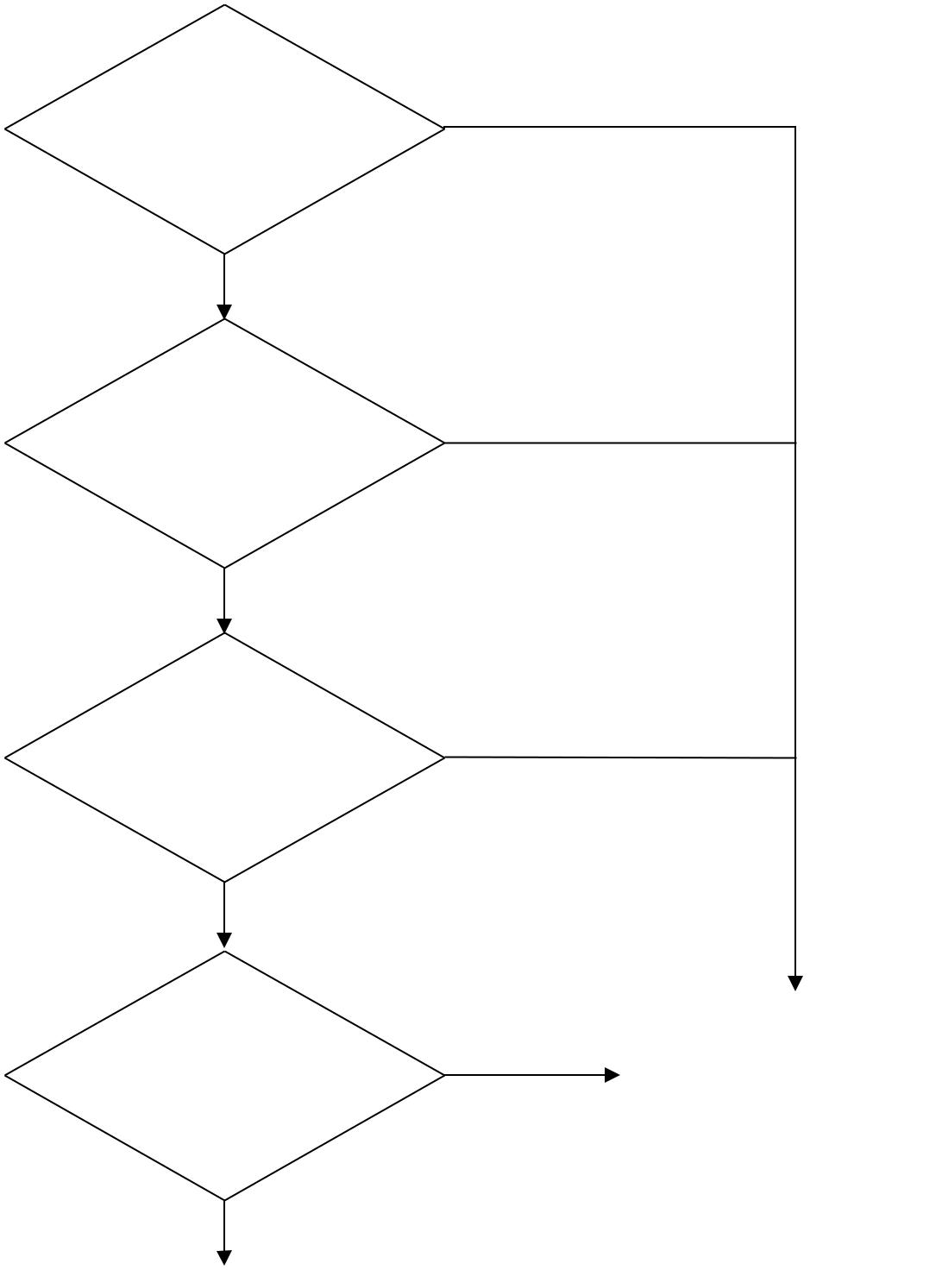

From same Product
Owner?

No

Yes

Same risk | No
classification (either | No
Class B only or
Class C only)?
Yes
Based on FISH | No
methodology?

Yes
Falls within the
Falls within the |  | Cannot be submitted
same listed FISH | No | Cannot be submitted
same listed FISH | No | as one FISH Probes
probes IVD |  | IVD application; refer
Grouping |  | IVD application; refer
Grouping |  | to GENERAL GROUPING CRITERIA guidance
Category? |  | to GENERAL GROUPING CRITERIA guidance
Category? |  | document for other
Yes |  | grouping options
Can be submitted as
one FISH Probes IVD
grouping category
application

Example:

Product Owner is “EFDA”

1 Class B FISH Probes IVD

grouping category
(e.g. Selective Therapy)

EFDA ABC FISH

Probes Kit for
selective therapy

EFDA XYZ FISH

Probes Kit for
selective therapy

Figure 5 Example of a Class B FISH Probes IVD grouping category with 2 products within the category

Based on the example provided in Figure 5, the 2 FISH Probes IVD kits qualify for submission as one FISH Probes IVD grouping category of “Selective Therapy” and would be listed as 2 ERIS listings based on their proprietary names:

- EFDA ABC FISH Probes Kit (Selective Therapy)*

- EFDA XYZ FISH Probes Kit (Selective Therapy)**

- EFDA ABC FISH Probes kit as one listing in which EFDA is the product owner and ABC is the proprietary name.

- EFDA XYZ FISH Probes kit as one listing in which EFDA is the product owner and XYZ is the proprietary name.

  - DEVICE SPECIFIC GROUPING OF IN VITRO FERTILISATION MEDIA

In vitro fertilization (IVF) is a procedure in which eggs (ova) from a woman's ovary are removed. They are fertilised with sperm in a laboratory procedure, and then the fertilised egg (embryo) is returned to the woman's uterus.

IVF is a medical procedure where an egg is fertilised by a sperm outside the body: in vitro. IVF instruments and media are necessary to ensure this medical procedure is performed successfully. IVF media products are used in a wide range of in vitro procedures, involving processing, manipulation and conditioning of sperm, oocytes, blastocysts and embryos. The intended use of IVF media may range from maintenance of the physiological homeostasis required to support and promote fertilisation in vitro, to the maintenance of the physiological homeostasis of the cells during the cryopreservation process and the minimisation of cellular damage during the freezing process. IVF media products may be comprised of a cocktail of physiological inorganic salts, energy sources, amino acids and proteins, and are available in a range of different formulations available.

A device specific grouping of IVF media grouping category comprises of a collection of IVF media that are:

- from the same product owner;

- compatible when used together and intended to be used for an IVF procedure category as listed below

When IVF media products satisfy the criteria to be grouped into one of the prescribed IVF media grouping categories, they can be grouped together and submitted in one application for registration. In cases where the IVF media products have different device proprietary names, they may be grouped together during the product registration submission. However, the products will be listed separately on the ERIS based on their proprietary names.

The device name listed on the ERIS upon approval will be based on the proprietary name and the IVF Media grouping category used during product registration.

Alternatively, product owners and their applicants may choose to group these devices using the general grouping criteria in General Grouping Criteria.

    - LIST OF IVF MEDIA GROUPING CATEGORIES

The list of IVF Media grouping categories is a closed and positive list.

 | S/N |  | IVF Media | Examples of Media Types
 |  |  | Grouping Category | (non-exhaustive list)
 |  |  | (closed list)
 | 1 |  | IVF Media for | (i) | Oocyte Obtaining
 |  |  | Oocyte Handling | (ii) | Oocyte Processing
 |  |  |  | (iii) | Oocyte In Vitro Maturation
 |  |  |  | (iv) | Oocyte Polar Body Biopsy
 |  |  |  | (v) | Oocyte Cryopreservation
 |  |  |  | (vi) | Oocyte Storage
 |  |  |  | (vii) | Oocyte Thawing
 |  |  |  | (viii) | Oocyte Transport
 | 2 |  | IVF Media for Sperm | (i) | Semen/Sperm Obtaining
 |  |  | Handling | (ii) | Semen/Sperm Processing
 |  |  |  |  | (e.g. gradient, swim up, immobilisation,
 |  |  |  |  | washing)
 |  |  |  | (iii) | Semen/Sperm Cryopreservation
 |  |  |  | (iv) | Sperm Storage
 |  |  |  | (v) | Sperm Thawing
 |  |  |  | (vi) | Sperm Transport
 | 3 |  | IVF Media for | (i) | IVF with Insemination
 |  |  | Zygote Handling | (ii) | IVF with Intracytoplasmic Sperm Injection
 |  |  | (processing/media | (ii)
 |  |  | (processing/media |  | (ICSI)
 |  |  | for maintenance of | (iii) | Zygotes Maintenance
 |  |  | zygotes/etc) | (iii) | Zygotes Maintenance
 |  |  |  | (iv) | Zygote Intrafallopian Transfer (ZIFT)

 | S/N |  |  | IVF Media | Examples of Media Types
 |  |  |  | Grouping Category | (non-exhaustive list)
 |  |  |  | (closed list)
 | 4 |  |  | IVF Media for In vitro | (i) | In Vitro Embryo Obtaining
 |  |  |  | Embryo Handling | (ii) | In Vitro Embryo Culture And Assessment
 |  |  |  |  | (iii) | In Vitro Embryo Biopsy
 |  |  |  |  | (iv) | Assisted Hatching
 |  |  |  |  | (v) | In Vitro Embryo Cryopreservation
 |  |  |  |  | (vi) | In Vitro Embryo Storage
 |  |  |  |  | (vii) | In Vitro Embryo Thawing
 |  |  |  |  | (viii) | In Vitro Embryo Transport
 |  |  |  |  | (ix) | Embryo Transfer (Et)

Decision Flowchart for Grouping of IVF Media Products
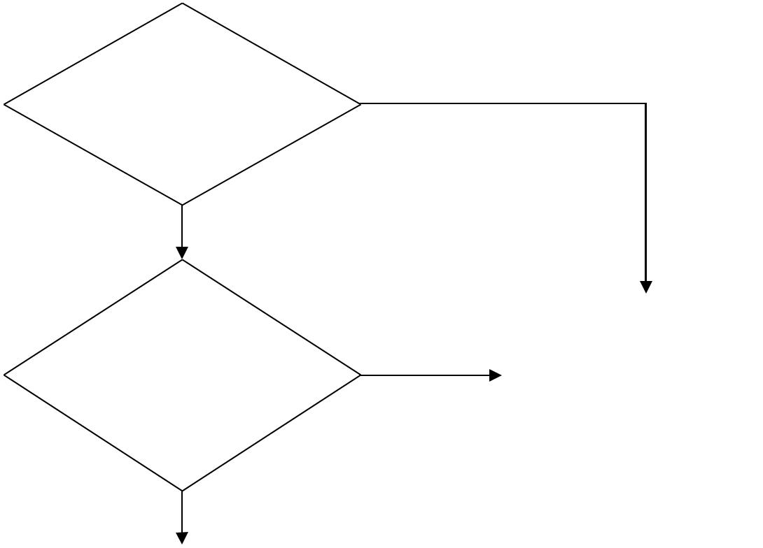

From same Product
Owner?

No

Yes

Compatible when |  | Cannot be submitted
Compatible when |  | as one IVF Media
used together and | No | as one IVF Media
used together and | No | application; refer to
falls within the same |  | application; refer to
falls within the same |  | GENERAL GROUPING CRITERIA guidance
listed IVF Grouping |  | GENERAL GROUPING CRITERIA guidance
listed IVF Grouping |  | document for other
Category? |  | document for other
Category? |  | grouping options
Yes
Can be submitted as one
device specific grouping
application for IVF Media


  - DEVICE SPECIFIC GROUPING OF IVD ANALYSERS

IVD analysers are equipment intended to be used with IVD reagents so as to allow the IVD reagents to achieve their intended use. IVD analysers are typically instruments that analyse the reaction and yield a result of positive, negative, amount of analyte detected, etc.

An IVD analyser FAMILY is a collection of IVD analysers. Each analyser in the

FAMILY fulfills the following criteria:

- Same product owner;

- Same proprietary name;

- Same risk classification;

- Same methodology / principles of operation; and

- Differences among analysers fall within a list of permissible variants.

The IVD analyser FAMILY may contain accessories of the same or lower risk class if these accessories are specifically intended to be used with the analysers in the FAMILY.

Applicants may choose to list IVD analysers with their respective IVD TEST KITS using the IVD SYSTEM grouping criteria described in GENERAL GROUPING CRITERIA Guidance on Grouping of Medical Devices for Product Registration – General Grouping Criteria or to list IVD analysers separately as part of an IVD analyser FAMILY in a SPLIT listing.

    - LIST OF PERMISSIBLE VARIANTS FOR IVD ANALYSER FAMILY

Kindly refer to the table below for permissible and non-permissible variants for the IVD analyser FAMILY.

 | Permissible Variants |  | Non-Permissible Variants
1. Features that do not impact the |  | 1. Features that impact the
diagnostic function |  | diagnostic function or lead to different
• | throughput | performance characteristics for their
• | throughput | compatible reagent kits for example
• differences in user interface
 |  | but not limited to:
• | printing function | • | sensitivity
• | wireless capability | • | specificity
• | software | • | linearity
• | sample volume | • | measuring range
• | onboard stability | 2. | Methodology/ principles of
• | calibration frequency | operation

Decision flowchart for grouping of IVD analysers as a FAMILY

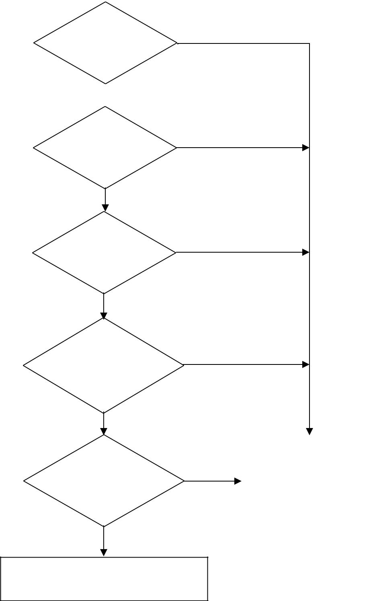

From same
product owner?

Yes

Same proprietary name?

Yes

Same risk classification?

Yes

Have same methodology/
principle of operation?

Yes

Analysers fall within permissible
variants?

Yes
Can be grouped in one listing

No

No

No

No

No | Cannot be
 | grouped in 1
 | listing.

